Eco International

Established in 2007 as ECO-INTERNACIONAL PENINSULA DE NICOYA, SOCIEDAD ANÓNIMA, in Costa Rica

Eco International is a builder of quality and distinction!

Our consulting services include, writing contract terms,
property assessment, subdividing, building and landscaping according to Vastu principals.

In addition, we knowingly apply the principals of “LEED”; Leadership in Energy & Environmental Design.

We knowingly apply and offer the principals of “LEED” *Leadership in Energy & Environmental Design, is a green building certification program that recognizes best-in-class building strategies and practices.

As an option, we can build according to “Vastu” or commonly called “Feng shui”, to establish harmony with the individual, nature and the home itself. The evidence indicates a greater harmony with nature and a very nourishing environment for the family.
Inception 2004 Established in 2007 as ECO-INTERNACIONAL
PENINSULA DE NICOYA, SOCIEDAD ANÓNIMA, COSTA RICA

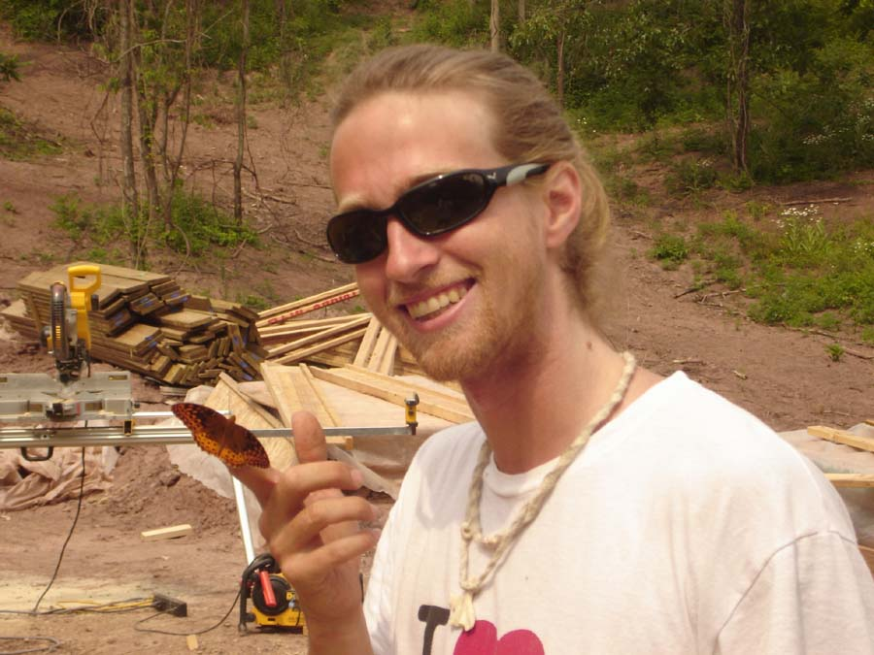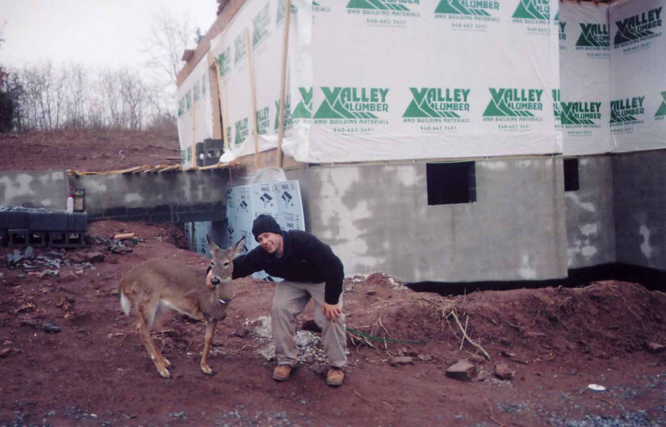

Bambu an Eco International design

Bambu has 14 estates _ 750 m2 to 7,300 sq. m.

Bambu, Cabuya, Costa Rica

Private drive: at the end of a public road

Public Sanitation service on public road at Bambu Entrance.

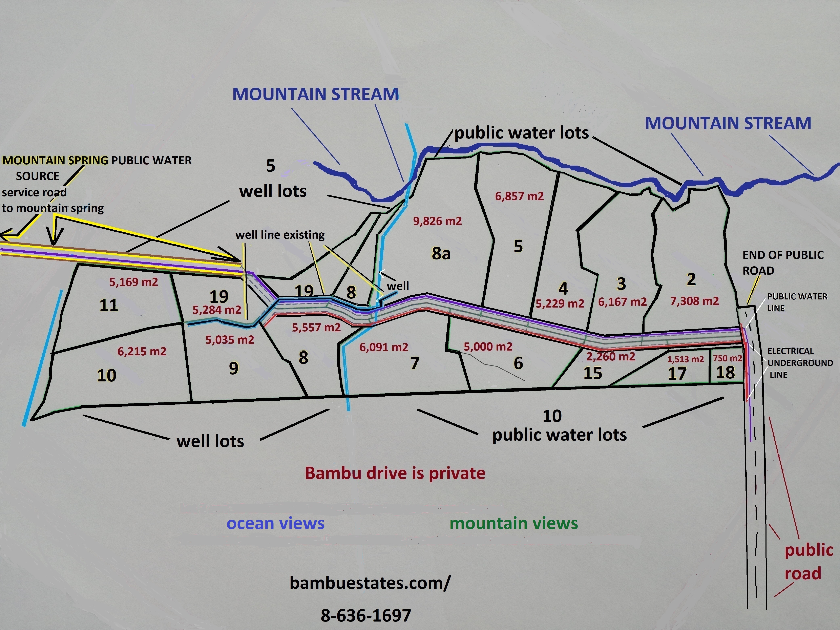

Some concepts

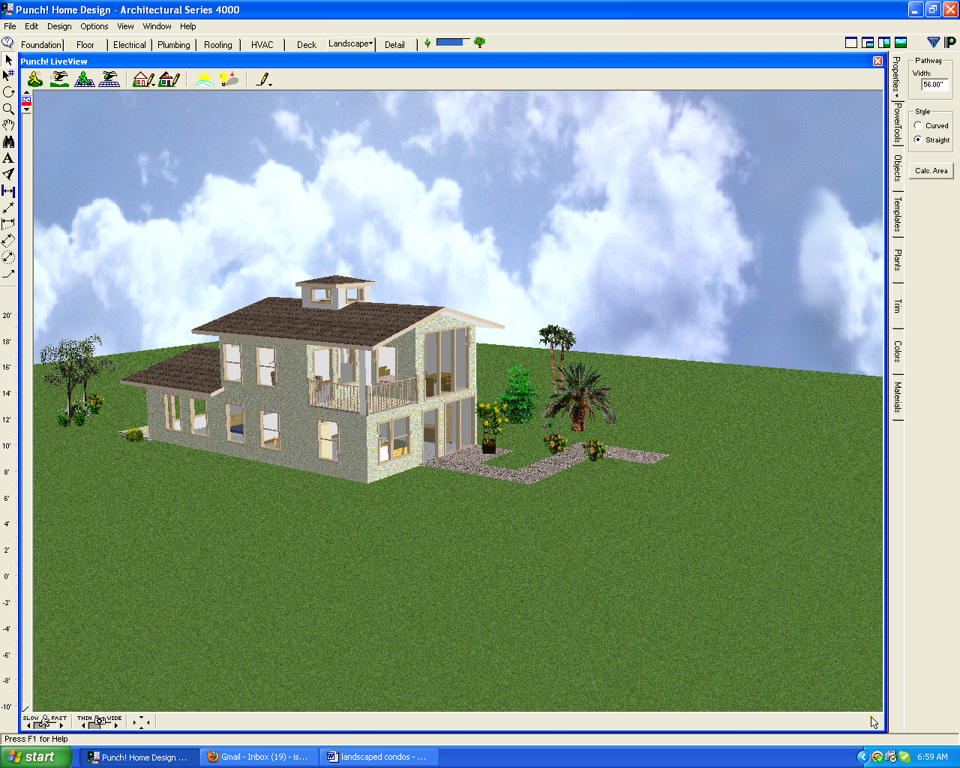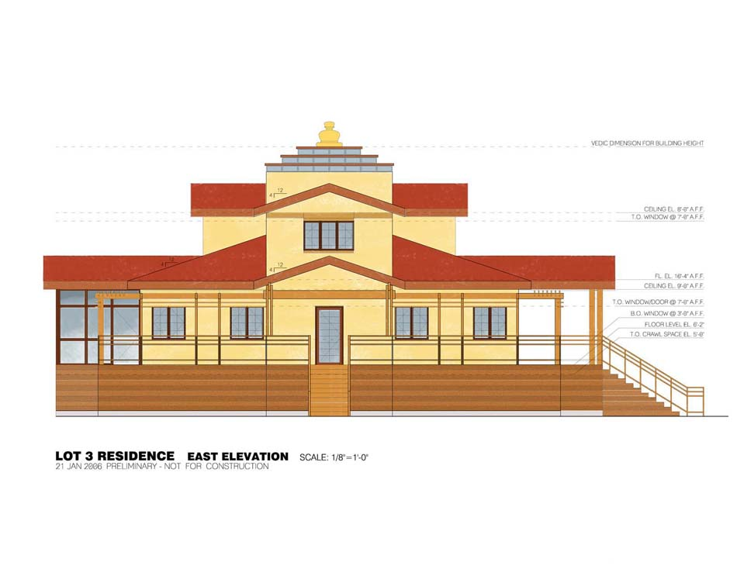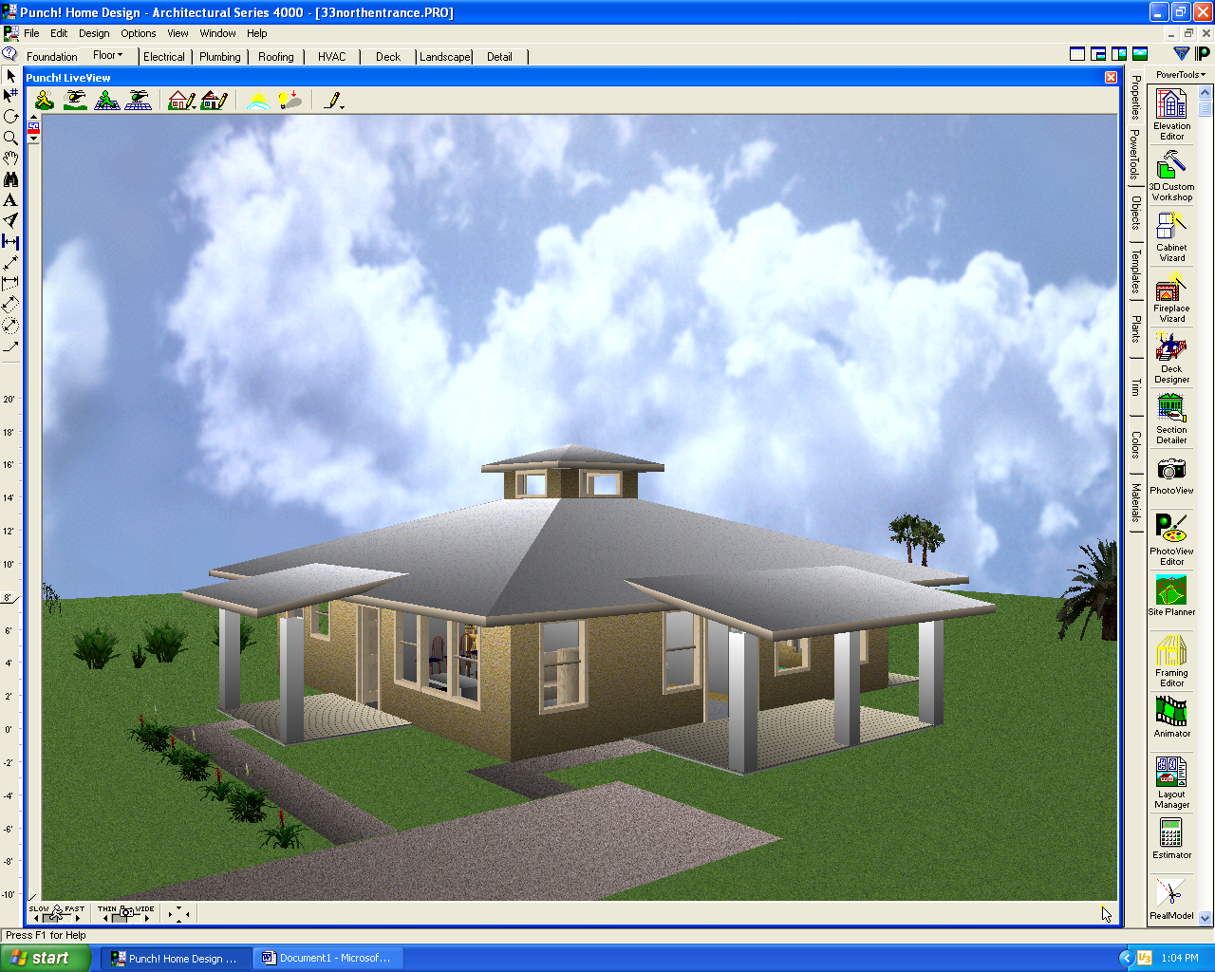

Some reality
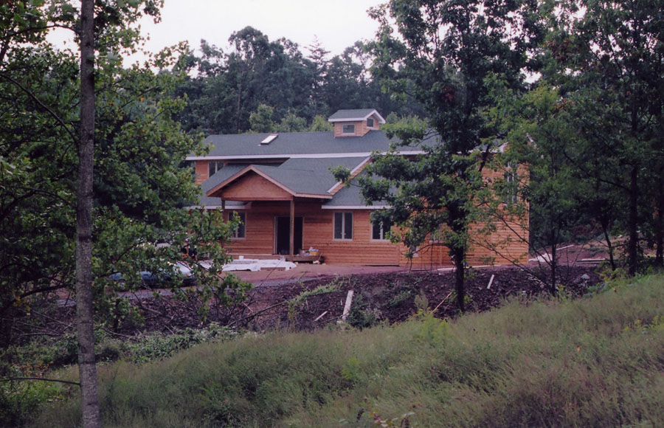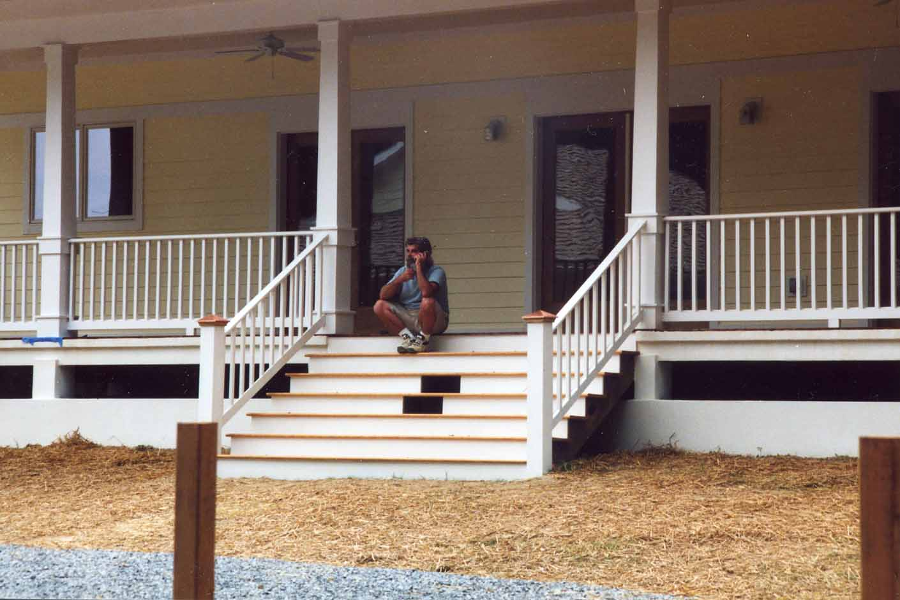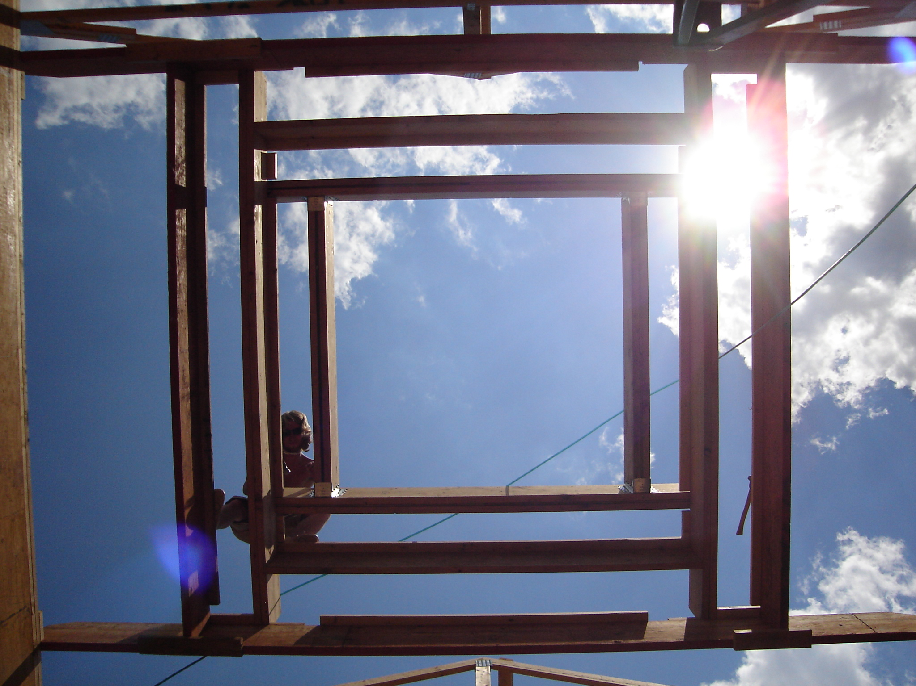

Offering Premium block; wo0d and or steel frame construction
1090 to 8,400 sq. ft. for main structure

Including but not no limited to___ Solar hot water_ sky lighting_ Minimized EMF_ no outgassing paints

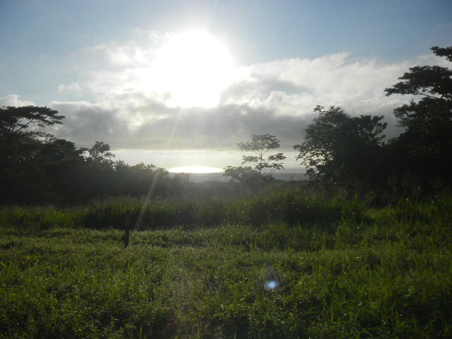

Sunrise at ¨Bambu¨

Eco International All rights reserved.

